Alphabet Chart
An alphabet chart is a tool used for reciting, reinforcement, and pointing. This chart should not be written on. See next page.

Copyright © 2023

Alphabet Chart
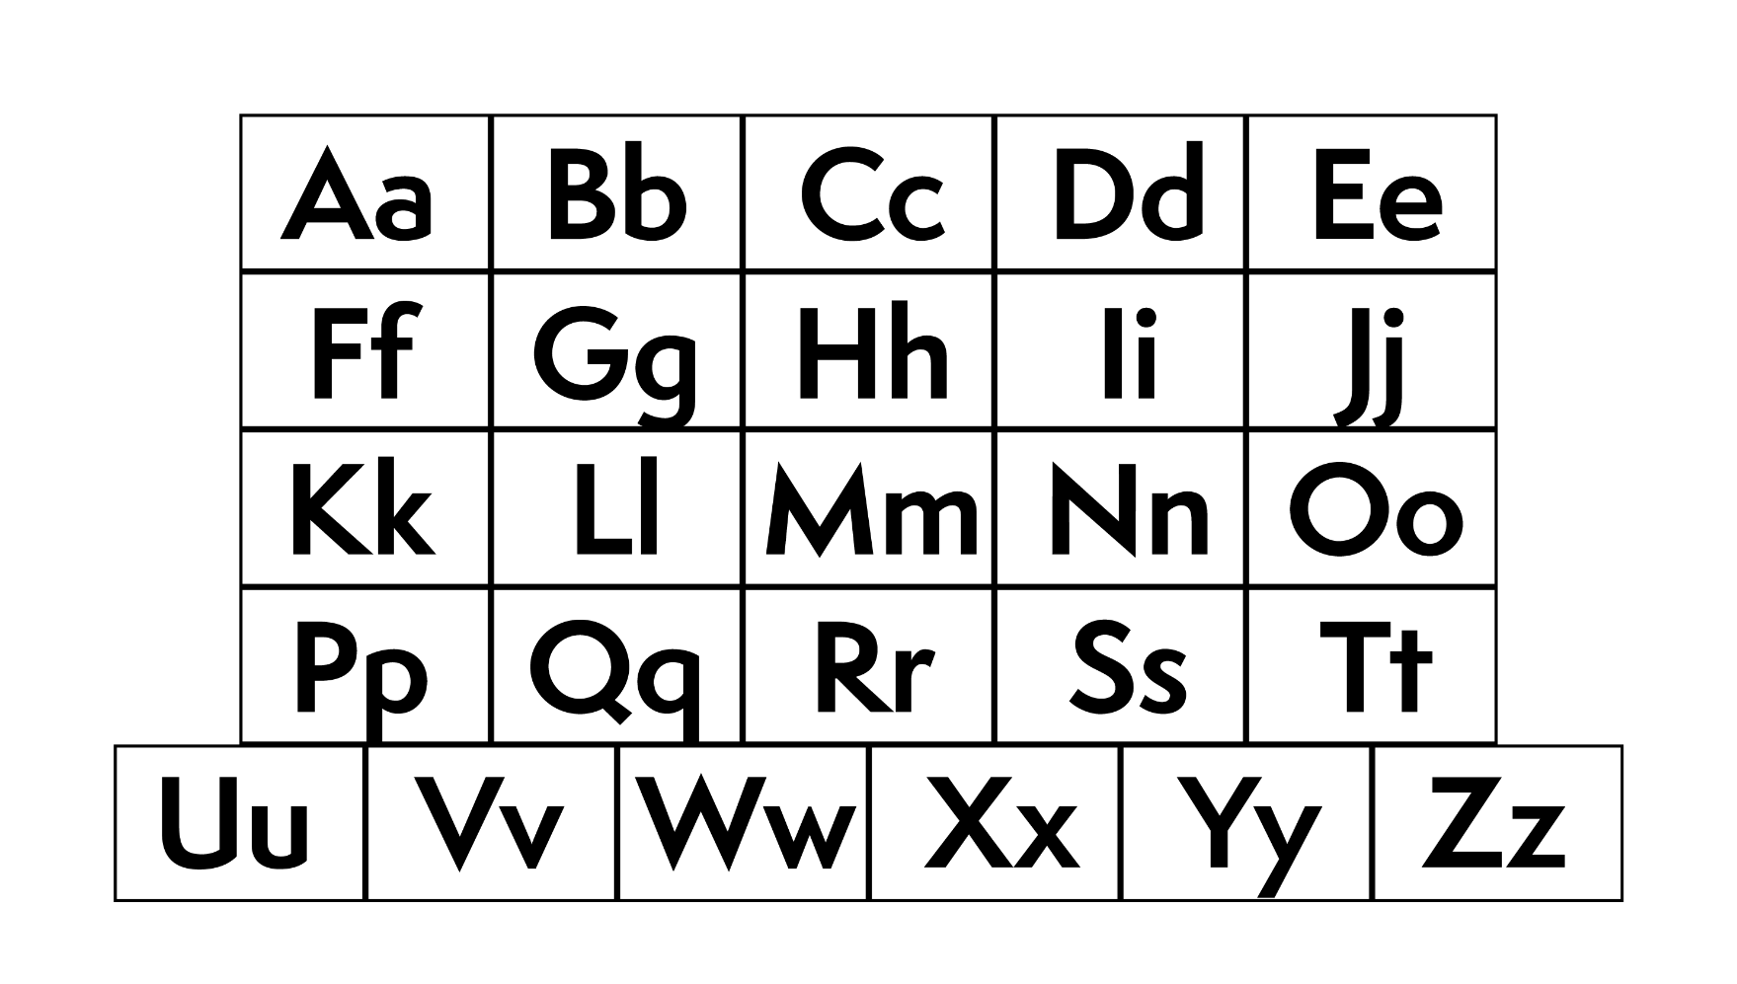

Copyright © 2023

